# *Table of Contents*

Getting Started……………………………………………………………………………………..………………………………..2

Installing the Software.……………………………………………………………………………...………………….………..3

**Interface..**…………………………………………………………………………………….…………………………………………

Creating a Scenario……………………………………………………………………………….……………………4

Importing a Scenario.…….……..……………………………………………………………..……………...………5

Create an Audio File….……………………………………………..……………………………...………………….6

Troubleshooting…………………………………………………………………………………………………………….………7

Contact Us…………………………………………………………………………………………………………………………………………8

# Getting Started

Welcome to your new Authoring App created especially for educators by CRS Inc. We hope you enjoy using this software just as much as we enjoyed creating it for you.

If you are new to using the Treasure Box Braille, please make sure to read the instruction manual that came with your device.

Run the Treasure Box Braille device and start creating with the Authoring App!

# Installing the Software

**Accessing Through GitHub**

1. Follow this link: <https://github.com/samank3/CRS_Group3>
   1. *Optional: read the “README” file
2. Click on the **RELEASE** panel
3. To run the application, click on **Authoring.jar**
4. The file will be saved in your directory and you may now run it locally

**Accessing Files Through Your Computer**

1. Open the **CRS_Group3-vM** folder within **CRS_Group3-vM**
   1. Make sure the folder is extracted first
2. Documentation contains the user manual, requirements testing, and documentation
3. Enamel contains all the source code, libraries, and example files to run Authoring App
4. Open up Eclipse
   1. Click **Import** > General > **Existing Projects into Workspace** > Browse to the directory containing **CRS_Group3-Vm** > **Finish**
5. Ensure you have the latest update of Authoring App **vM1.0**
   1. Please Contact Us (Page 8) if you are experiencing difficulty opening the file or do not have the latest version of Authoring App

# Interface

**Creating a Scenario**

To create a scenario for your TBB, you must know the script that you would like to make.

Click “Create Scenario”

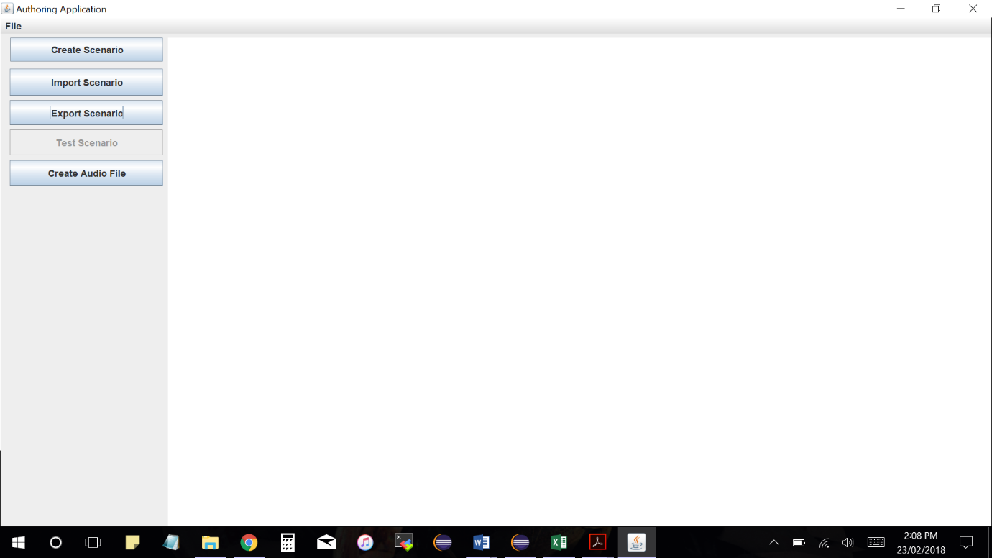

You will be prompted with the following options:

* Enter Number of Braille Cells to Use
* Enter Number of Buttons to Use

Please enter a valid number for each prompt

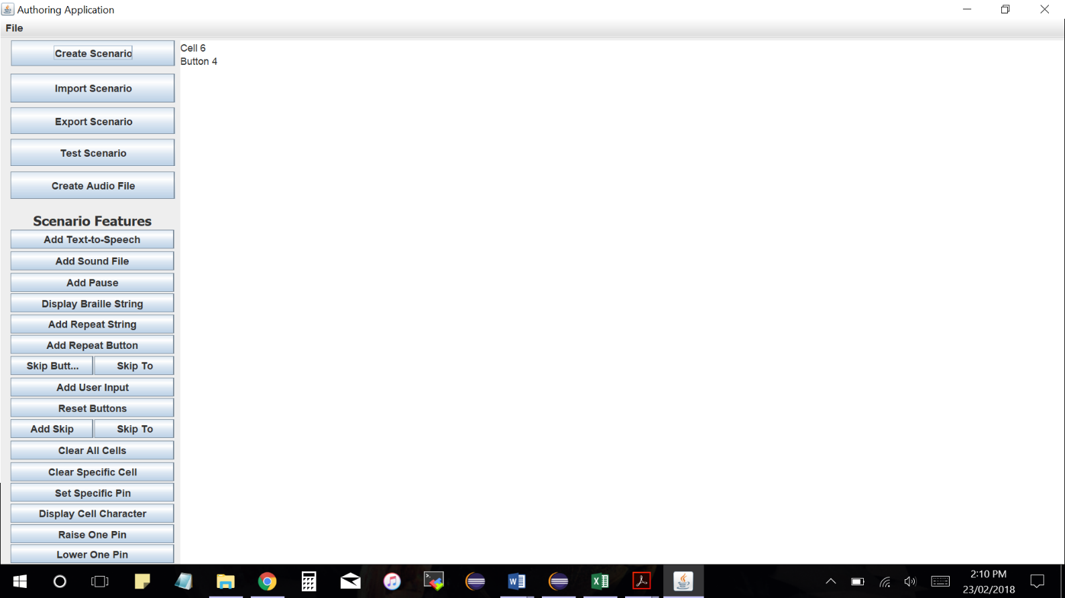

You will then be presented with several options:

Click on the corresponding buttons to create the desired script.

Please keep in mind that your input must follow conditions. If a condition is not met, the Authoring App will notify you and you will be asked to try again.

After you are satisfied with your script, click on “Export Scenario” on the left, and save your script.

The script will be saved as a text (.txt) file and can be loaded for future use (See “Importing a Scenario” on Page 4).

# Interface

**Importing a Scenario**

As an Authoring App user, you may want to import other scripts, view your own scripts, or test to see if it is running correctly. You may import any script as long as the file is in text (.txt) format.

To import a script:

1. Select **Import Scenario**
2. Find the desired directory and file, and select **Open**
3. The script will be displayed on the right pane

Example of a *Factory Scenario* loaded

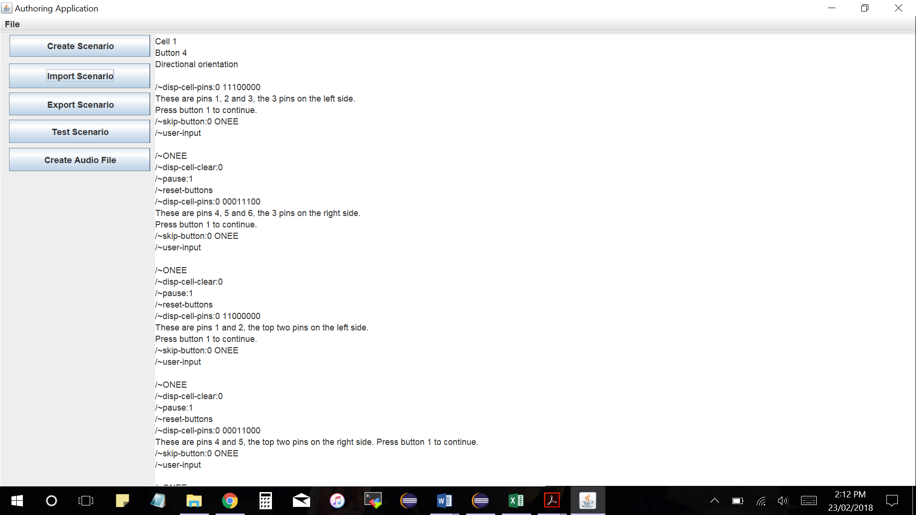

# Interface

**Creating an Audio File**

The Authoring App allows you to record and save an audio file. This recording can be used to help your students understand scripts better.

1. Select **Create Audio File**
2. Enter a file name which your audio will be saved to
3. Enter the duration (in seconds) of the audio file which you will record
4. You will be informed that upon clicking **Yes**, the recording will commence. If you would like to cancel the recording, select **No** – the audio file will not be saved.
5. After the recording is complete, the audio file will be saved in your directory.

# Troubleshooting

The Authoring App is a simple and intuitive application which educators can use. However, users can run into trouble or may have a hard time learning how to operate the application.

Here are some common cases a user may run into:

|  |  |
| --- | --- |
| **Conflict** | **Troubleshooting Suggestion** |
| I am unable to import a script I previously created in Authoring App. | Did you save it as a .txt file? Remember to add the extension “.txt” to the file name when you are saving a script, so the Authoring App can display it correctly |
| I am trying to record an audio file but no sound is being recorded. | Ensure the mic on your laptop or external device are working and connected correctly. Relaunch the Authoring App and try again. |
| I am using a Windows device and NVDA does not recognize some text. | NVDA can cause some issues with Authoring App since the user’s environment (32-bit or 64-bit) may vary. Please try the following solution.   1. Control Panel > Ease of Access Center > “Use the computer without a display” > Scroll to the bottom and ensure that **Enable Java Access Bridge** is toggled ON.   If this does not fix your issue, please contact us and we will try our best to find a solution for your device |

# Contact Us

Please do not hesitate to contact our team at CRS Inc. with any questions or concerns about this product. We would love to hear any feedback you have about the Authoring App and are always looking for ways to improve!

To contact the individual developers of CRS Inc.:

**Rudra Sharma** (905) 234-5678 | [rsharma@CRSInc.com](mailto:rsharma@CRSInc.com)

**Christopher Tsung** (416) 667-8899 | [ctsung@CRSInc.com](mailto:ctsung@CRSInc.com)

**Saman Khan** (416) 123-7890 | [skhan@CRSInc.com](mailto:skhan@CRSInc.com)

**Get in Touch!**

[info@CRSInc.com](mailto:info@CRSInc.com)

(416) 560-9304

4700 Keele St.

Toronto, ON

M3J 1P3

*Thank you for choosing a CRS Inc. product! We promise the best user experience possible*